FIT5229 - Masters thesis final
SEMESTER 1, 2024
Final Thesis

Title: Exploring microRNA-mRNA Relationships Mediated by Transcription Factors in Melanoma

Author Name: Mansi Aggarwal
Student ID: 32639104
Supervisor: Dr. Miles Andrews
Co-Supervisors: Peinan Zhao, Dr. Ranjeeta Menon
Date Created: 28 March 2024
Date Modified: 25 May 2024
Word Count: 6,728

Table of Contents
1. Abstract 3
2. Background 4
2.1. Regulators of gene expression 4
2.2. Coordinated activity of TF and miRNA 5
2.3. Measurement and normalisation strategies for gene and miRNA expression 6
2.4. Predicting miRNA targets 7
2.5. Limitations of sequencing-based approaches to resolving miRNA-mRNA interactions 8
3. Methodology 10
3.1. Data Collection 10
3.2. Data Preparation 10
3.3. Correlation Analysis 10
3.4. Identification of miRNA-TF interactions 11
3.5. Identification of TF target genes 11
3.6. Over-representation analysis 11
4. Results 14
5. Discussion 23
6. References 25

Abstract

MicroRNAs (miRNAs) are small RNA molecules, measuring around 22 nucleotides in length, that bind to specific target sequences on messenger RNAs (mRNAs) and control gene expression. This binding results in translational repression, which lowers the production of proteins from those mRNAs (Fattore et al., 2017; Friedman et al., 2009). However, transcription factors (TFs), which are essential for controlling gene networks in a variety of biological systems, are also targeted by miRNA (Zhao et al., 2016).

Conventional methods for identifying miRNA targets often rely on correlations between miRNA and mRNA expression levels (Joung et al., 2007). However, this approach may overlook indirect regulatory relationships, particularly when miRNAs target transcription factors (TFs), which themselves control expression of the target gene through DNA binding.

This study aims to explore the interplay between miRNAs, TFs, and mRNAs. Utilising publicly available gene and miRNA expression datasets, we employed correlation analysis to identify strongly correlated miRNA-mRNA pairs and investigated the potential involvement of intermediary TFs in these interactions. Our approach focused on identifying miRNAs that directly target TFs but not the mRNAs that those TFs regulate, yet still have a statistically significant high correlation with those mRNAs. This may suggest a possible miRNA-TF-mRNA regulatory network where the high correlation could be attributed to the intermediate TF. We discovered a significant number of miRNA-mRNA pairs exhibiting strong correlations, many involving potential intermediary TFs, highlighting the complexity of the gene regulatory network in melanoma and the crucial role of miRNA-TF-mRNA interactions. Further investigation into these regulatory networks could provide valuable insights into the molecular biology of melanoma.

Background

Regulators of gene expression
The central dogma of molecular biology states that genes guide protein synthesis through messenger RNA (mRNA) molecules. Since the information carried by genes cannot be converted into proteins directly, information is first transferred to complementary coding mRNA molecules produced from a DNA template in a process called transcription. Each mRNA molecule encodes information for one protein and migrates through the nuclear envelope to the cytoplasm, where it may undergo additional modification (e.g. splicing) prior to being translated into protein by the ribosome. Simplistically, the quantity of mRNA molecules should be directly related to the quantity of the protein it encodes. However, this process is complex due to multiple regulatory mechanisms that directly influence protein production and degradation. Recent findings have elucidated the roles of miRNAs and TFs as the two main classes of molecules that influence gene expression and protein synthesis (Guzzi et al., 2015).

TFs regulate gene transcription through binding to specific sites in the DNA near target genes (Chen & Rajewsky, 2007; Suter, 2020; Wang et al., 2015). These binding sites, known as transcription-factor binding sites (TFBS), often form clusters called cis-regulatory modules (CRMs). CRMs, spanning hundreds of nucleotides, can contain multiple binding sites for around 3 to 10 transcription factors, producing the initial spatio-temporal expression patterns of target genes by integrating concentrations of various transcription factors present within a specific cell at a given time. This reliance on cellular context and combinatorial control underscores the intricate nature of transcriptional regulation (Chen & Rajewsky, 2007).

Melanoma progression is also influenced by a number of TFs. Microphthalmia-associated transcription factor (MITF) is a key regulator in melanocyte development and differentiation. MITF governs the expression of a multitude of pigmentation genes, facilitating melanocyte differentiation, while also regulating fundamental genes crucial for cell homeostasis. These include genes encoding proteins involved in apoptosis, such as BCL2, and those governing the cell cycle, such as CDK2 (Kawakami & Fisher, 2017).

TFs also play a crucial role in melanoma invasiveness. SOX10 and PAX3 cooperate to activate MITF expression, crucial for melanocytic lineage development. Melanocytic precursors migrate to the epidermis (outer layer of skin), proliferate, and differentiate into pigment-producing melanocytes under the regulation of MITF, SOX10, and PAX3 (Wessely et al., 2021).

Small non-coding RNAs (ncRNAs) have also been discovered to control gene expression in a sequence-specific manner. High-throughput sequencing and computational prediction methods have classified ncRNAs into small interfering RNAs (siRNAs), microRNAs (miRNAs), PIWI-interacting RNAs (piRNAs), endogenous small interfering RNAs (esiRNAs), promoter associated RNAs (pRNAs), small nucleolar RNAs (snoRNAs), and sno-derived RNAs – miRNAs being the most important regulators of gene expression (Catalanotto et al., 2016).

MiRNAs primarily bind to the 3' untranslated region (UTR) of their target mRNAs based on sequence complementarity, although interactions with the 5' UTR and coding regions have also been observed (Hofacker, 2007). The fate of an mRNA after miRNA binding depends on the degree of complementarity in this so-called seed sequence; complete seed sequence binding leads to mRNA degradation, while partial binding results in translational repression, often during translation initiation (Bartel, 2004).

Coordinated activity of TF and miRNA
In development, TFs act as switches to turn genes on or off, while miRNAs regulate gene expression and cellular development (Flynt & Lai, 2008). Dysregulation of miRNAs can lead to disease, particularly in cancer. In fact, Lu et al. (2005) reported the potential of using miRNA expression profiles over mRNA expression profiles in cancer diagnosis for classification of tumour states. The expression patterns of miRNA are tissue and stage-specific, influenced by transcriptional regulators, signaling networks, and chromatin modifiers (Arora et al., 2013). TFs regulate miRNA expression through cell-specific pathways, often interacting with cis-regulatory motifs near transcription start sites.

Cui et al. (2007) observed that the complexity of transcriptional regulation of a given gene is positively correlated with the probability that the gene is regulated by a miRNA. Gene regulatory networks of CRM-miRNA modules are composed of feedforward loops (FFLs), where a TF and a miRNA jointly regulate a target gene (Arora et al., 2013). There are different types of FFLs, each with distinct regulatory effects on gene expression. In a miRNA-mediated FFL, the miRNA simultaneously represses a TF and its target gene. When the miRNA is downregulated, the target gene expresses, demonstrating a quick-OFF-slow-ON switching mechanism (Sevignani et al., 2006). This buffering of noise helps minimise leaky expression. An example of this type of FFL involves miR-208, GATA-4, and the target gene, α-myosin heavy chain (α-MHC), in cardiac muscle regulation. GATA-4 stimulates α-MHC expression, while miR-208 represses both GATA-4 activity and α-MHC expression, regulating cardiac hypertrophy.

In TF-mediated FFLs, the TF activates or represses both the miRNA and its target gene simultaneously. This can lead to either coherent or incoherent effects on target gene expression, depending on the regulatory relationships. In coherent TF-mediated FFLs, the TF either activates both the miRNA and its target gene or inhibits both. This results in a coherent effect on target gene expression, with both pathways having the same effect. An example of a coherent TF-mediated FFL is observed between TGF-β, miR-29, and cardiac fibrotic genes in the heart. TGF-β negatively regulates miR-29, which, in turn, suppresses cardiac fibrotic genes. In contrast, an incoherent TF-mediated FFL can be seen between Pnt-P1, miR-7, and the target gene Yan in D. melanogaster, where the loop ensures inhibition of Yan expression by activation on miR-7.

Measurement and normalisation strategies for gene and miRNA expression
RNA-Seq is a protein coding RNAs (mRNAs) profiling methodology using Next Generation Sequencing (NGS) platforms to investigate all RNA in a sample, typically after selection or enrichment for mRNA species (Sa et al., 2018). It converts total RNA into fragmented cDNA which is then amplified and sequenced in high-throughput. Current methods target RNAs with at least 200 base pairs, while short noncoding RNAs require separate isolation and protocols. Read lengths range between 30-500 base pairs depending on the sequencing platform, and library size or read depth is crucial for sensitive and precise transcript identification and quantitation.

RNA-Seq reads are computationally mapped to a human reference genome, revealing a transcriptional map (Wang et al., 2009). Alignment is challenging due to extensive alternative splicing and multiple short read assignments. The most popular RNA-Seq alignment software packages employ gene annotation to improve spliced read placement and, in the great majority of cases, appropriately handle multiple short read assignments (Sa et al., 2018).

In RNA-Seq studies, a technical bias arises due to the impact of gene length and library size on the estimation of gene abundances. Larger genes tend to have higher read counts compared to smaller genes simply because they produce longer mRNAs (Abbas-Aghababazadeh et al., 2018). R/FPKM (reads/fragments per-kilobase transcript per million mapped reads) are a commonly reported measure of normalised gene expression from RNA-Seq analysis. For RPKM (single-end sequencing), total reads in a sample are divided by 1,000,000 to obtain a "per million" scaling factor. Read counts are divided by the scaling factor to normalise for sequencing depth, resulting in reads per million (RPM). RPM values for each gene are further divided by the length of that gene in kilobases to calculate RPKM. FPKM is the equivalent metric for paired-end RNA-seq, where two reads (forward and reverse) uniquely identify each original transcript fragment, and ensures that fragments are not counted twice due to paired-end sequencing.

TPM (transcripts per kilobase per million) normalisation divides read counts by gene length to obtain reads per kilobase (RPK), then scales these values to ensure a constant sum of one million across samples, simplifying inter-sample comparisons. The difference here is the order of operations — we first normalise for gene length first, and then normalise for sequencing depth.

TPM is unit-less and adheres to the invariance property — because it normalises expression levels by the total number of transcripts in the sample, ensuring that the average expression level is consistent across samples (Zhao et al., 2020). It represents the normalised transcript abundance per gene, maintaining proportionality and facilitating compatibility with modern computational algorithms for transcript quantification, such as RSEM (Li & Dewey, 2011). TPM is widely used for gene expression analysis, particularly for comparison across samples.

In the case of miRNA, mature miRNA is the active species that binds to the 3′ UTR of mRNA; quantification of the mature miRNA, rather that the inactive, pre-miRNA, is usually desirable (Schmittgen et al., 2008). Studies have shown that pre-miRNA is often detectable while mature miRNA is undetectable (Michael et al., 2003). Small RNA-seq using NGS offers a powerful method for miRNA expression profiling as well, enabling detection of known and novel miRNAs with precise identification of sequences, including variants differing by a single nucleotide (Alexiou et al., 2020; Pritchard et al., 2012). However, NGS-based studies may yield numerous small RNAs of novel sequence, necessitating rigorous criteria for miRNA annotation. Emerging technologies like single molecule sequencing (SMS) promise less biased output but face challenges of higher error rates and cost (Pritchard et al., 2012).

Currently, the practice for normalising small RNA-seq experiments is scaling to library size. This technique divides reads by the total number of short RNA-seq reads aligning to the genome. Alternatively, normalising miRNA reads against the overall count of 18–22 nucleotide reads or the total number of reads that map to known miRNAs, respectively, yields the relative frequency of miRNAs. After normalisation, the data is reported for each library as reads per million (Meyer et al., 2010).

Predicting miRNA targets
Numerous computational techniques were developed to discover putative miRNA targets in the lack of high-throughput biological approaches.

Sequence-based miRNA prediction approaches – such as TargetScan (John et al., 2004), and miRanda (John et al., 2004) – utilise computational algorithms to scan the 3' UTRs of target genomes for potential miRNA binding sites (John et al., 2004; Lewis et al., 2003; Liu et al., 2014). These algorithms typically consider factors such as sequence complementarity between the miRNA and target site, predicted binding energy of the miRNA-target duplex, and evolutionary conservation of the target site sequence. Predicted target genes are identified based on conserved pairing to the miRNA and the number and quality of complementary sites.

However, most statistical approaches in standard sequence analyses are unable to detect miRNAs significantly regardless of the binding sites due to their short length. Since some miRNAs lack conserved targets, most algorithms use the cross-species conservation criterion to lower the number of false positives, even if there is a chance that this may increase the number of false negatives (Liu et al., 2014).

MiRNA target predictions can be experimentally validated using both gene-specific and high-throughput techniques. Importantly, the sheer number of potential miRNA targets is largely unfeasible to validate experimentally using high confidence techniques. Gene-specific methods include reporter gene assays, co-expression analysis of miRNA and target mRNA (e.g., northern blotting or qPCR), and evaluation of the impact of miRNA on target proteins (e.g., ELISA, western blotting, immunohistochemistry) (Kuhn et al., 2008). High-throughput techniques extend these methods to a larger scale, such as using microarray screening instead of qPCR. They also include novel methods like RNA-Seq, (micro)RNA-induced silencing complex (RISC) component immunoprecipitation, high-throughput sequencing of RNA isolated by crosslinking immunoprecipitation (HITS-CLIP), photoactivatable-ribonucleoside-enhanced crosslinking immunoprecipitation (PAR-CLIP), biotin-tagging of miRNAs, parallel analysis of RNA ends (PARE), and various proteomics approaches like SILAC (Thomson et al., 2011), which involves crosslinking immunoprecipitation to isolate mRNA transcripts associated with the miRISC from cellular lysates (Chi et al., 2009; Liu & Wang, 2019). This technique captures short RNA fragments, or transcript tags, which are protected from RNase digestion by RISC-associated Argonaute proteins. The captured RNA fragments are then subjected to high-throughput sequencing to identify their sequences.

Despite the accuracy of above experiments in identifying miRNA-target genes, these methods do not specify which regions of the mRNA are targeted by miRNAs. To locate the specific regions, luciferase reporter assays are extensively used (Hsu et al., 2011) and involve fusing the 3′ UTR of a target gene to a luciferase reporter construct and validation occurs by observing changes in reporter activity detected by luminescence. This helps pinpoint specific mRNA regions involved in miRNA targeting, providing direct confirmation of miRNA-mRNA interaction (Xiao et al., 2009).

Limitations of sequencing-based approaches to resolving miRNA-mRNA interactions
Based on the notion that the canonical action of microRNA is to reduce gene expression of target genes, miRNA-mRNA associations identified through inverse correlation of paired miRNA and RNA sequencing data are ubiquitous throughout the literature, fuelled by the high-throughput and relative simplicity of next generation sequencing. Such approaches can be paired with experimental validation leading to discovery of new biological insights (Andrews et al., 2016). However, because miRNA act post-transcriptionally, the most appropriate strategy would be to examine correlations between miRNA abundance and matched quantitative whole-proteomics, but such data are expensive to produce and complex to analyse. Furthermore, as not all miRNA-target mRNA interactions lead to degradation of the target mRNA, the validity of sequencing-based inverse correlations is questionable and subject to potentially large numbers of false positive and negative associations.

Refined probabilistic or correlation-based approaches also exist to identify miRNA-regulated modules by integrating miRNA-target binding information and expression profiles of miRNAs and mRNAs (Joung et al., 2007). The method combines heterogeneous data sources using a fitness function, incorporating correlation coefficients between miRNA or mRNA pairs and binding scores of miRNA-mRNA pairs. Through co-evolutionary learning and estimation-of-distribution algorithms, optimal groups of miRNAs and mRNAs are mined iteratively, enabling the detection of correlated miRNA-mRNA modules with biological significance, as demonstrated in a human cancer dataset.

Le et al. (2013) proposed a causal modelling and discovery approach to infer causal regulatory links between miRNA and mRNA from gene expression data; and the results of the subsequent gene knockdown studies were shown to share a significant amount of overlap with the identified miRNA–mRNA causal regulatory connections. This result has shown that the computational method can obtain a high level of accuracy. However, this approach, and most approaches, still do not differentiate if the causal linkages are direct, or indirect – where an indirect regulation of an mRNA by a miRNA is mediated by other regulator(s), such as TFs.

To address this limitation, we focused on exploring the role of TFs acting as intermediaries of observed miRNA-mRNA correlations in sequencing datasets. We hypothesised that miRNAs could indirectly regulate mRNAs by targeting TFs that, in turn, control the expression of those mRNAs. To test this hypothesis, we specifically searched for instances where a miRNA directly targets a TF but not the TF's target genes, yet still exhibits a statistically significant correlation with those genes. This approach allowed us to identify potential miRNA-TF-mRNA regulatory networks where the observed correlations can be attributed to the indirect influence of the miRNA through the intermediary TF. By considering TFs as potential mediators, our study aimed to provide a more nuanced understanding of the complex regulatory landscape governing gene expression in melanoma.

Methodology

Data Collection
We used data from the SKCM (Skin Cutaneous Melanoma) cohort of The Cancer Genome Atlas (https://portal.gdc.cancer.gov/projects/TCGA- SKCM). TCGA is a large, curated collection of multi-platform genomic, clinical, and pathologic data, for over 20,000 cancer and/or matched normal samples spanning 33 cancer types, obtained via international collaboration. The SKCM dataset includes miRNA expression profiling by small-RNAseq (available for 452 cases) and gene expression profiling by mRNA-seq (available for 473 cases).

Processed count data summarised at gene and miRNA level respectively was downloaded using the TCGAbiolinks (Colaprico et al., 2016), R/Bioconductor package (v2.29.6).

Data Preparation
The expression data were cleaned and processed before further analysis. For clarity, gene expression refers to mRNA sequencing-derived abundance quantified as “Transcripts Per Kilobase Million” (TPM), and microRNA expression refers to mature-strand microRNA abundance derived from small RNA sequencing and quantified as “Reads Per Million Mapped” (RPM).

- Protein-coding filter: Gene expression data were filtered to retain only protein-coding transcripts.
- Sample-ID harmonisation: Sample IDs were matched and made consistent across both datasets.
- Dataset matching: Only samples with matched gene and miRNA data (n=451) were retained for further analysis.
- Removal of non-expressed features: Genes and miRNAs with no expression (i.e.: TPM or RPKM, respectively) across all samples were removed from further consideration.
- Expression prevalence filter: Low-prevalence genes/miRNAs, being genes/miRNAs expressed in less than 40% of samples, were filtered out.
- Log-transformation: The final expression data matrices were log₂ transformed (after adding a dummy count of 1 to all observations to avoid infinity values) to stabilise variance across different expression levels (Law et al., 2014).

For gene expression data, gene symbols and ENSEMBL IDs were retained for downstream analysis.

Correlation Analysis
We calculated the Spearman correlation coefficient between each gene and each miRNA as this non-parametric measure is best suited to monotonic correlations in genomic data unlike the Pearson coefficient, which requires normally distributed data for linear relationships (Siska & Kechris, 2017). Correlation coefficients and their associated p-values were calculated using the “rcorr” function in the Hmisc package in R (Harrell Jr, 2023). Statistical significance was adjusted for multiple comparisons using the Benjamini-Hochberg (BH) procedure in order to calculate the False Discovery Rate (FDR). Correlations with an adjusted p-value of less than 0.05 were retained for further analysis. No threshold was set for correlation coefficient.

Identification of miRNA-TF interactions
A list of known human TFs identified through functional characterisation of over 1600 likely TFs and binding motifs was downloaded in csv format as provided by Lambert et al. (2018). Potential TF genes were filtered for “Is.TF” = “Yes”.

We used the multiMiR (Ru et al., 2014) package in R (v1.20.0) to obtain miRNA-target interactions. The multiMiR database includes data from 14 external databases, including validated, predicted, and disease-/drug-related databases. These data were downloaded and pre-processed before loading into multiMiR’s MySQL database.

To obtain miRNA-TF interactions, we queried interactions in the multiMiR database that had been experimentally validated using any technique (such as luciferase reporter assays, western blot, qRT-PCR, immunohistochemistry, immunoprecipitation) — and then retained miRNAs shown to target any of TFs in the list obtained from Lambert et al. (2018), as above.

Identification of TF target genes
Chromatin immunoprecipitation sequencing (ChIP–seq) is widely used to map DNA-binding proteins and histone modifications in a genome-wide manner at base-pair resolution (Park, 2009). To determine the genes targeted by TFs, we used ChIP-Atlas, a web service of comprehensive ChIP-seq datasets (Zou et al., 2022). This study involved aligning the data to the human reference genome (hg38) and performing peak calling. Significant peaks indicative of TF-binding sites were identified, and genes with peaks overlapping with transcription start site regions within a specified distance were considered as potential TF targets.

For each TF in the list from Lambert et al. (2018), we downloaded the list of genes that demonstrated significant TF binding within 5000 base pairs of the gene’s transcription start site.

Over-representation analysis
Over-representation analysis (ORA) is a method used in bioinformatics studies to evaluate whether a list of genes is over-represented in or by a previously annotated gene set or pathway (Karp et al., 2021).

We implemented an over-representation analysis, using the method of Boyle et al. (2004) who described the inference of statistical significance of overlapping gene sets by calculating a p-value using the hypergeometric distribution according to the following formula:

$$p=1-\sum_{i=0}^{k-1}{\frac{\left({M \atop i}\right)\left({N-M \atop n-i}\right)}{\left({N \atop i}\right)}}$$

Here, $N$ is the total number of genes in the background distribution, $M$ is the number of genes within $N$ that are annotated, either directly or indirectly, to the node of interest, $n$ is the size of list of genes of interest and $k$is the number of genes within this list that are annotated to the node. In our example, $N$, i.e. the background is the entire gene expression matrix (17,381), $M$ represents the subset of $N$ that are target genes of FOXC1 (i.e., 13,589 genes), $n$ is 1,681 (being genes that are positively correlated to miR-639), and $k$ is 1,357 (the number of genes that overlap between miR-639 correlated and FOXC1 target genes). Assuming the hypergeometric distribution of sampling without replacement, when randomly sampling $n$ genes from the background gene set $N$, the p-value represents the probability of having $k$ genes overlapping with the annotated set of $M$ genes. This ORA thus provides a statistical assessment of whether a substantial portion of the gene correlations with the miR of interest are likely to be a consequence of the action of the intervening TF under consideration.

By way of example, let us consider a miR-639. It positively correlated with 1,681 genes and is known to interact with the TF FOXC1. Out of the 17,381 in our final gene expression matrix, FOXC1 is known to target 13,589 genes. Now we find that of the 1,681 genes that positively correlate with miR-639, 1,357 are also found within the 13,589 genes targeted by FOXC1. We wish to know if the correlation between miR-639 and these 1,357 overlap genes involves direct miR-mRNA interactions, or whether there is evidence that it could be mediated indirectly by the miR-FOXC1 interaction. In our example, $N$, i.e. the background is the entire gene expression matrix (17,381), $M$ represents the subset of $N$ that are target genes of FOXC1 (i.e., 13,589 genes), $n$ is 1,681 (being genes that are positively correlated to miR-639), and $k$ is 1,357 (the number of genes that overlap between miR-639 correlated and FOXC1 target genes).

Notably, for miRs that interact with multiple TFs, performing separate overlap analyses for each TF targeted by a miRNA is crucial to accurately assess their regulatory network interactions. Pooling all interacting TFs and their target genes may lead to misleading conclusions in ORA because the more TFs a miR targets, the more of the genome those TFs would target collectively, thus the overlap proportions of miR-target genes and pooled TF-target genes would be expected to be almost universally high and not reflective of the potential molecular interaction between the miR and any single TF.

To perform ORA, we used “clusterProfiler”, an R/Bioconductor package (Wu et al., 2021). When first released in 2012, this suite of tools performed functional enrichment analyses from gene expression data by querying the enrichment of biological or metabolic functional annotations in an input gene set of interest, against functional gene databases such as GO and KEGG. However, now, clusterProfiler also supports more generalised ORA of any input and reference gene sets using the “enricher” function. This function accepts a parameter called TERM2GENE, a data frame with first column of term ID and second column of corresponding mapped gene – this data frame is a user-specified custom annotation list. All mRNAs used for correlation analysis formed the background set (here, ID was “background”). Then, for each TF, we created a gene set consisting of its target genes that were also present in the background set (here, ID was “TF target”, e.g., “FOXC1 target”). This allowed us to investigate whether miRNA-correlated genes (positively or negatively correlated) were over-represented among the targets of TFs known to interact with that miRNA, providing insights into potential two-step regulatory mechanisms. If the miRNA was known to interact with multiple TFs, the ORA was performed for each TF separately.

Results
The TCGA-SKCM dataset was retrieved for miRNA expression which was available for 452 cases and for gene expression which was available for 473 cases. Normalised gene and miRNA expression data (TPM for gene expression, RPM for miRNA expression) were obtained. The sample IDs were matched across both datasets. Datasets were pre-processed to remove non-expressed and low prevalence features (expressed in <40% of samples), and log₂-transformed. These steps produced a final dataset comprising expression data for 17,384 genes and 779 miRNAs across 451 matched cases, suitable for downstream correlation analysis, and produced expression data for 17,384 genes and 779 miRNAs across 451 matched cases.

Pairwise Spearman correlation analysis identified a substantial number of significantly (adjusted p < 0.05) correlated miRNA-mRNA pairs: 1,991,908 positive correlations and 1,115,724 negative correlations.

By integrating ≥1600 known human TFs and previously experimentally-validated miRNA-target interactions, we identified 165 miRNAs that displayed significant correlations with mRNAs including interaction with at least one TF. In total, there were 3306 interacting miRNA-TF pairs as some miRNAs were known to target multiple TFs.

We further assessed the significance of indirect interactions through TFs, for which, we employed over-representation analysis (ORA). This analysis examined whether genes correlated with a specific miRNA were statistically over-represented among the targets of TFs known to interact with that miRNA. Of the 779 miRs analysed, 165 were found to target at least one TF. Of these 165 miRs, 65 had significant overlap between the miR’s negatively correlated genes and targets of TFs that the miR interacts with, and 118 had significant overlap between the miR’s positively correlated genes and targets of TFs that the miR interacts with (Figure 1).

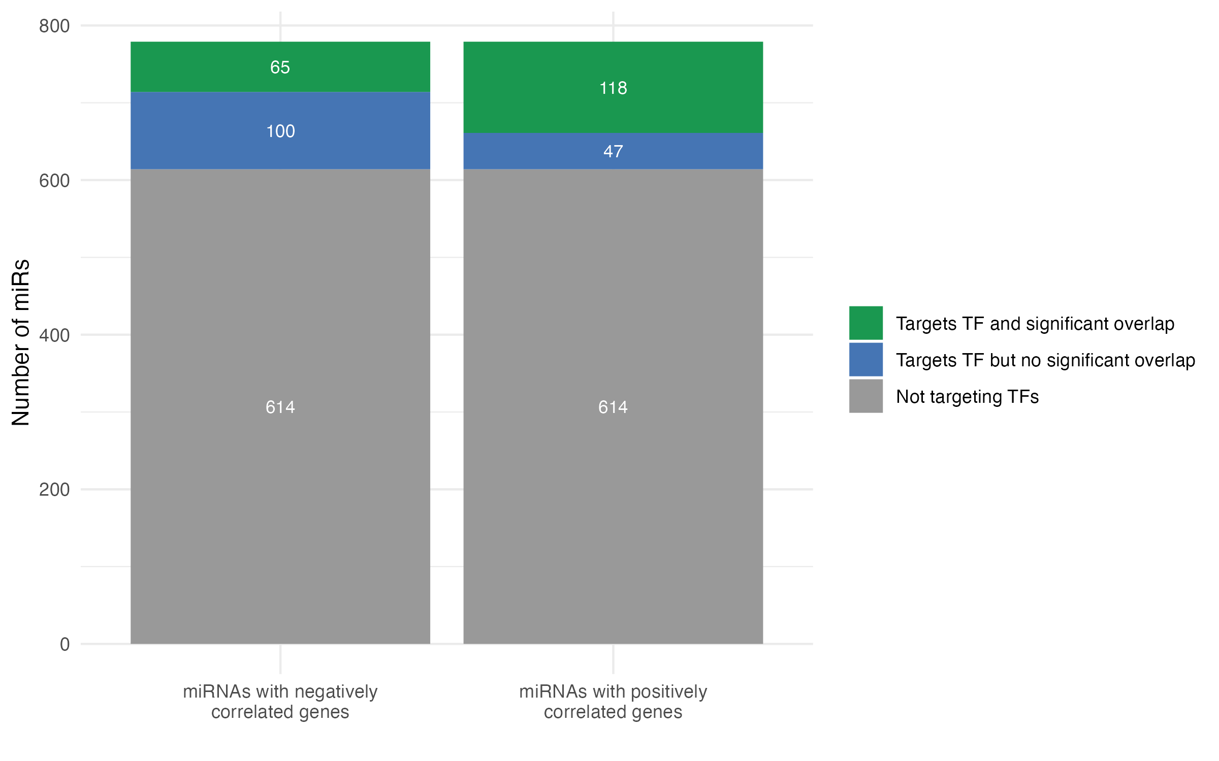
Figure 1. Distribution of miRNAs Based on Correlation with Genes and Overlap with TF Targets. All 779 miRNAs had statistically significantly positively and negatively correlated genes; 614 (grey) did not target a known TF whereas 165 miRNAs targeted at least one known TF. The green portion is the number of miRNAs where genes correlated with a specific miRNA were statistically over-represented among the targets of TFs known to interact with that miRNA. Blue indicates the number of miRNAs whose correlated genes were not significantly over-represented among the corresponding interacting TF.
There were 1518 miR-TF pairs that had a significant overlap (adjusted p-value < 0.05) between positively miR-correlated genes and TF target genes, and 638 miR-TF pairs having significant overlap between negatively miR-correlated genes and TF target genes. In these overlapping sets of miR-correlated and TF target genes, we retrieved the gene with the strongest correlation (highest absolute value correlation coefficient) with the miR. The miR-TF pairs were arranged in descending order of this correlation coefficient and then in ascending order of the q-value (for most significant overlap) (Figure 2).

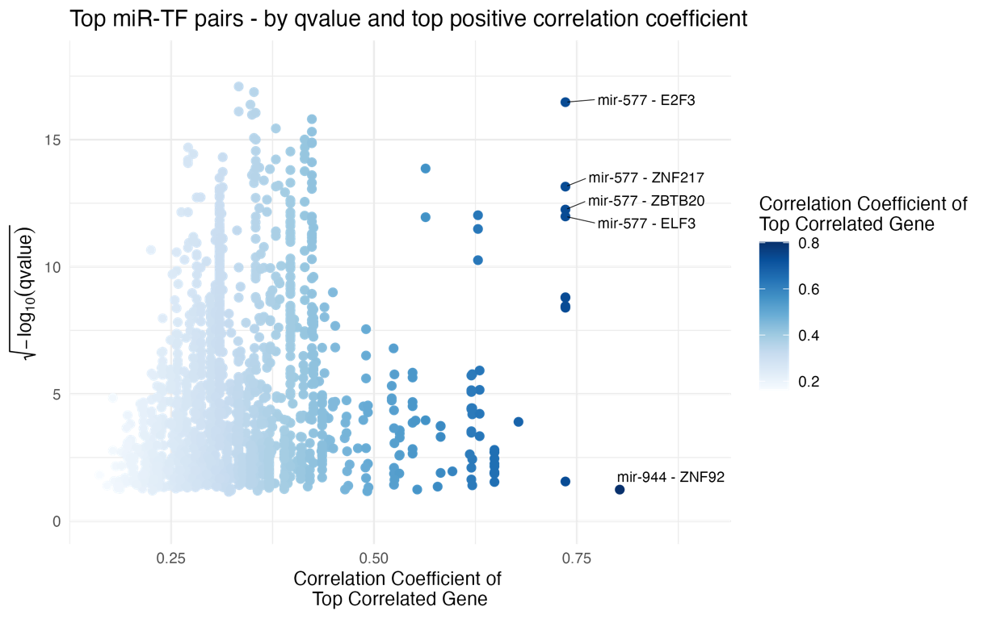
Figure 2. Scatter plot of the most highly-correlated gene for each miRNA-TF pair among the set of overlapping genes. 1518 miR-TF pairs had a significant overlap (adjusted p-value < 0.05) between miR’s positively correlated genes and target genes of TFs that the miR interacts with. In that overlapping gene set, the strongest correlated gene’s coefficient has been shown. The five annotated pairs represent those with the highest positive correlation coefficient and most significant overlap (least q-value).

miR-577 was present in 4 of out 5 top pairs. It positively correlated with 6580 genes and is known to interact with 38 TFs. UGT8 was the gene with the strongest positive correlation (0.736) with miR-577 among the overlapping gene set. UGT8 is not known to be directly targeted by miR-577 according to the multiMiR database, but is a target gene of the TFs E2F3, ZNF217, ZBTB20 and ELF3, all of which are themselves direct miR-577 targets. However, these TFs collectively target a substantial portion of the genome (9803, 11773, 11533, and 12914 genes respectively, out of 17381 background genes).

We conducted the same analysis for miRs with negatively correlated genes. The miR-TF pairs were arranged in descending order of the absolute (negative) correlation coefficient and then in ascending order of the q-value (Figure 3).
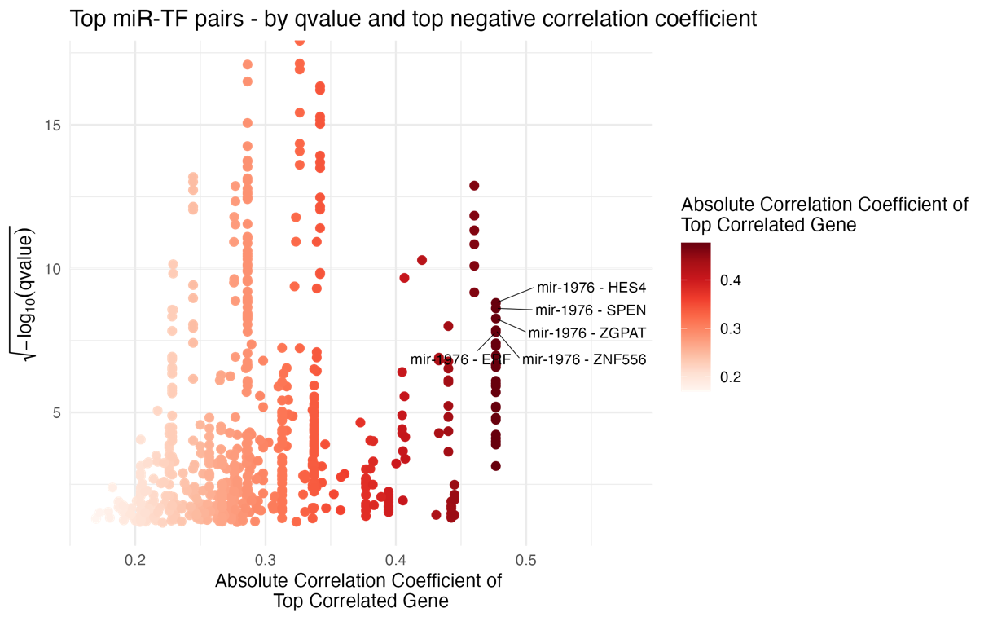
Figure 3. Scatter plot of the most highly-correlated gene for each miRNA-TF pair among the set of overlapping genes. 638 miR-TF pairs had a significant overlap (adjusted p-value < 0.05) between miR’s negatively correlated genes and target genes of TFs that the miR interacts with. In that overlapping gene set, the strongest correlated gene’s coefficient has been shown. The five annotated pairs represent those with the highest positive correlation coefficient and most significant overlap (least q-value).

miR-1976 targeted 62 TFs and had significant negative correlations with 5194 genes. All top 5 pairs had the same miR interacting with 5 TFs, which again collectively target a significant portion of the genome (HES4 – 10241 genes, SPEN – 11546 genes, ZGPAT – 11773 genes, ZNF556 – 9446 genes, and ERF – 12032 genes). The top correlated gene for all these pairs is INTS8 – with a correlation coefficient of -0.477. miR-1976 is not known to directly target INTS8 either.

We next sought to identify miR-TF pairs for which significant over-representation of TF target genes in miR-correlated genes were most likely to be explained by indirect TF actions rather than direct miR-mRNA interactions. To do this, we evaluated each significant miR-TF pair from ORA and determined the proportion of the overlapping gene set for which there was experimental evidence of direct miR-mRNA targeting using the multiMiR database. The results were sorted in descending order by the correlation coefficient of top correlated gene in the overlapping gene set, and in ascending for q-value (significance) and also in ascending order of the proportion of miR’s known direct targets in the overlapping gene set based on experimental validation retrieved using multiMiR — highly correlated genes to a miR and lower proportion of genes being direct target of that miR would suggest a strong likelihood of indirect regulation of the genes by the miR.

We observed the same pairs as seen in Figure 2. miR-577 not only has highly correlated genes, but also does not target most of these genes in the corresponding overlapping sets, suggesting that high correlations could more likely be due to indirect TF actions (Figure 4).
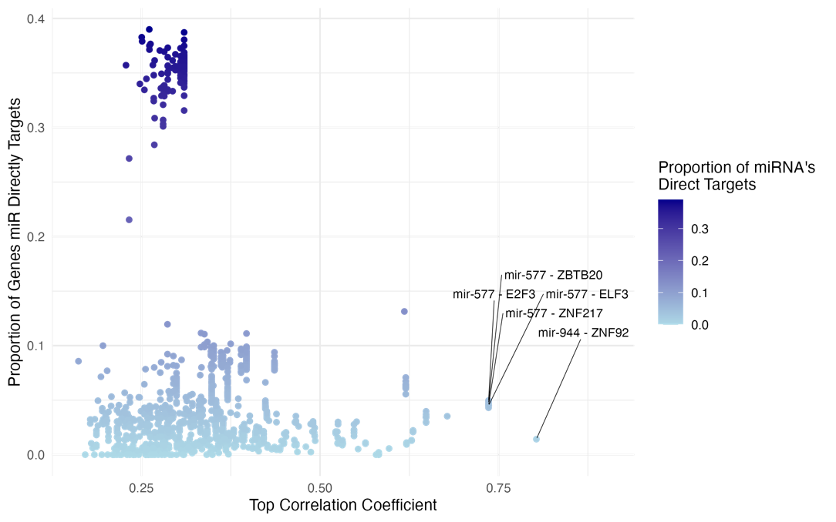

Figure 4. Scatter plot of the most highly-correlated gene for each miRNA-TF pair among the set of overlapping genes and the proportion of genes that miR directly targets in this set. This plot displays the top correlated gene for each miRNA-TF pair among the set of overlapping genes and the corresponding proportion of miR’s direct gene targets in that set. The five annotated pairs are those with the highest positive correlation coefficient, most significant overlap (by lease q-value) , and the least proportion of miR’s direct targets.

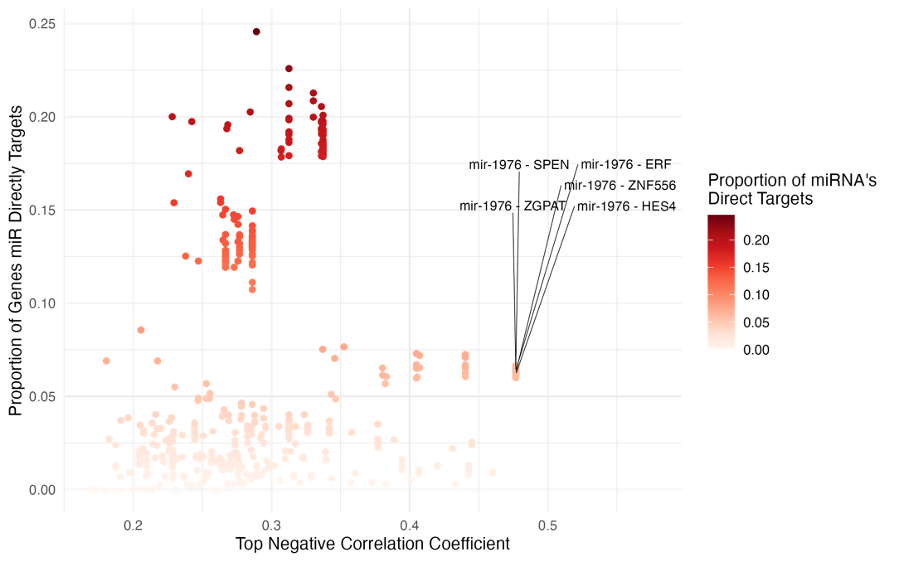
Figure 5. Scatter plot of the most highly-correlated gene for each miRNA-TF pair among the set of overlapping genes and the proportion of genes that miR directly targets in this set. This plot displays the top correlated gene for each miRNA-TF pair among the set of overlapping genes and the corresponding proportion of miR’s direct gene targets in that set. The five annotated pairs are those with the highest absolute (negative) correlation coefficient, most significant overlap (by lease q-value), and the least proportion of miR’s direct targets.
A similar pattern was observed among the miR-TF pairs for miRs with negatively correlated genes. We observed the same 5 pairs as in Figure 3, which shows the miR-1976 also does not directly targets most of the genes in the overlapping set(s), suggesting that high negative correlations could more likely be due to indirect TF actions rather than direct miR-mRNA interactions (Figure 5).

The putative indirect regulatory mechanisms mediated by TFs were further elucidated when we analysed the percentage of miR’s direct targets in for all overlapping gene sets where there was a significant over-representation of miR’s correlated genes in TF’s target genes set. Of the 1518 miR-TF pairs that had a significant overlap between positively miR-correlated genes and TF target genes, in 990 pairs, miRs were known to target ≤ 5% of the overlapping genes (Figure 6), and in 409 pairs out of 638 miR-TF pairs that had a significant overlap between negatively miR-correlated genes and TF target genes, miRs were known to target ≤ 5% of the overlapping genes (Figure 7).
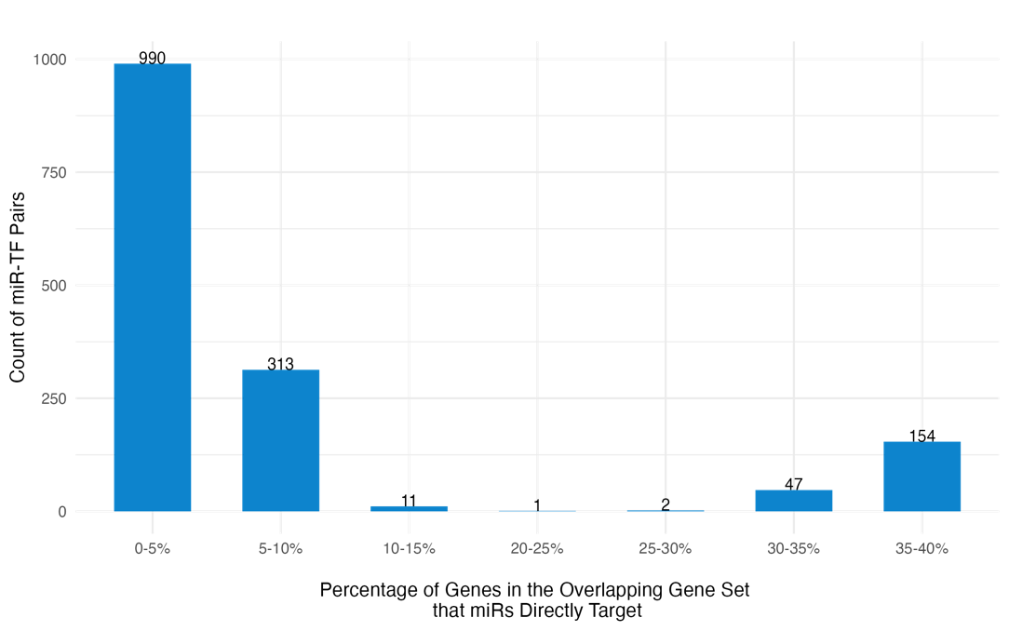
Figure 6. Proportion of genes directly targeted by the miRs in overlapping gene sets. This bar plot shows the distribution of miRNA-TF pairs based on the proportion of genes directly targeted by the miR within the overlapping gene set. The percentage of genes in the overlapping set of miR’s positively correlated genes and TF’s target genes are binned in increments of 5%.

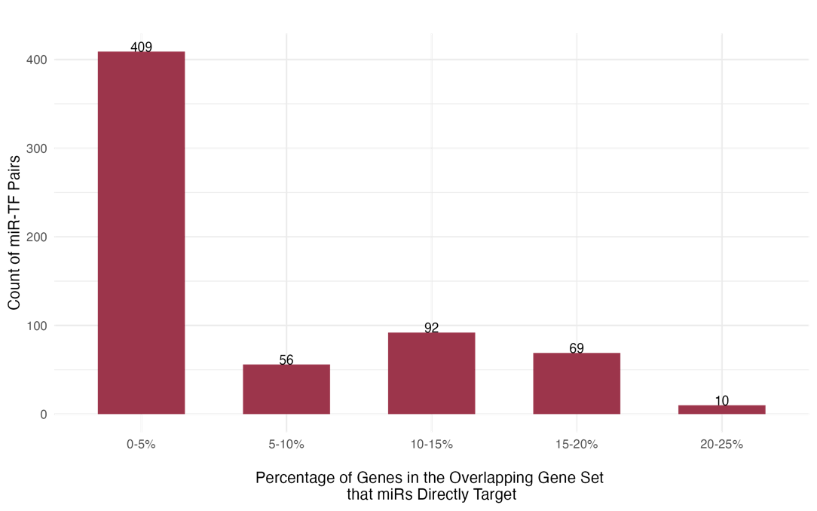
Figure 7. Proportion of genes directly targeted by the miRs in overlapping gene sets. This bar plot shows the distribution of miRNA-TF pairs based on the proportion of genes directly targeted by the miR within the overlapping gene set. The percentage of genes in the overlapping set of miR’s negatively correlated genes and TF’s target genes are binned in increments of 5%.
All the miR-TF interactions queried from multiMiR were experimentally validated, however, to refine our results, we focused on miR-TF pairs for which there was high-level evidence of direct interaction based on experimental validation using luciferase assays or western blot — there were 86 such pairs. Among these 86 pairs, for miRs with positively correlated genes, 29 miR-TF pairs showed a significant overlap and for miRs with negatively correlated genes, there were 23 pairs. MiRs that had interacted with the most TFs were miR-137, miR-107, miR-429, miR-449a, miR-320a, with miR-137 targeting the most TFs i.e., 13. And similarly, 5 TFs that had the highest number of interactions with miRs were MYC, SP1, KLF4, DNMT1, E2F3 — MYC had 5, the highest number of interactions.

miR-137 had the highest number of TFs as targets, and also the highest number of significant overlaps — 9. miR-137 also has lower expression levels in comparison to other miRs. miR-429 and miR-449a had a considerable number of TF targets, but no significant overlaps. MYC had interactions with 5 miRs, but only 1 significant overlap (Figure 8).
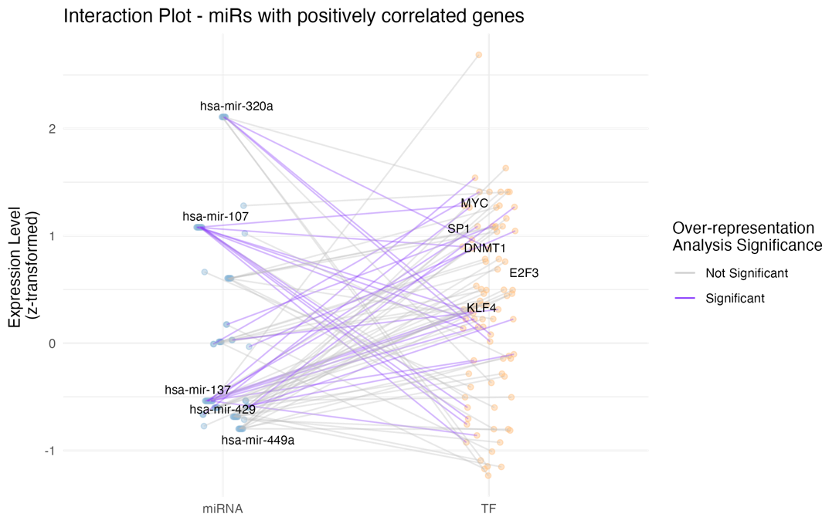
Figure 8. miRNA-TF pairs and over-representation analysis significance between miR’s positively correlated genes and targets of TF that the miR interacts with. This interaction plot the shows z-transformed expression level of miRs and TFs. Each connecting line represents a miR to a TF it is known to interact with, and the interaction being experimentally validated by luciferase assay reporters or western blotting techniques; the colour of the line indicates whether the overlap between the miRNA's positively correlated genes and the TF's target genes is significant.

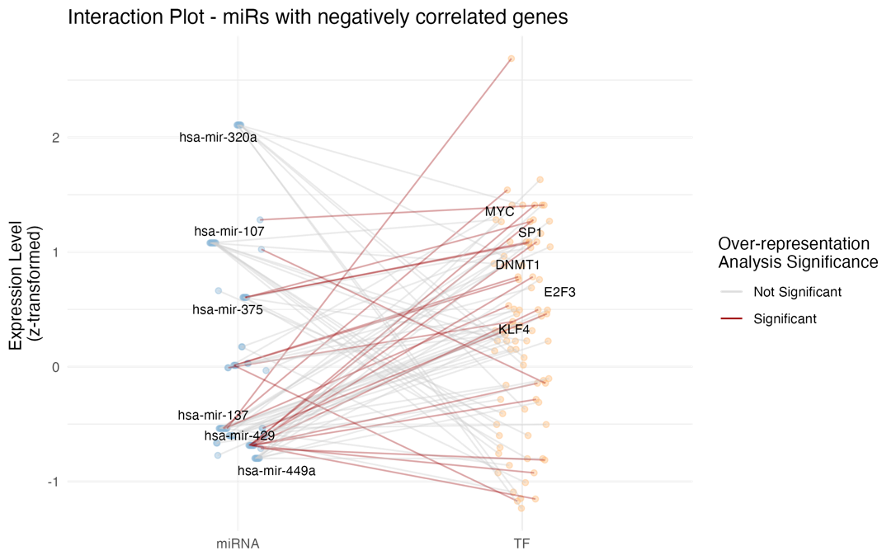
Figure 9. miRNA-TF pairs and over-representation analysis significance between miR’s negatively correlated genes and targets of TF that the miR interacts with. This interaction plot the shows z-transformed expression level of miRs and TFs. Each connecting line represents a miR to a TF it is known to interact with, and the interaction being experimentally validated by luciferase assay reporters or western blotting techniques; the colour of the line indicates whether the overlap between the miRNA's negatively correlated genes and the TF's target genes is significant.
miR-137 has few significant overlaps between its negatively correlated genes and the TF's target genes. For all the 9 TFs that miR-429 targeted, there was a significant overlap between the miR’s negatively correlated genes and the corresponding TF’s target genes (Figure 9).

Our findings, including the over-representation of miR-correlated genes among TF targets and identification of specific miR-TF pairs for which the significant over-representation was most likely to be explained by indirect TF actions rather than direct miR-mRNA interactions, suggest that intermediary TFs may play a crucial role in mediating indirect miRNA-mRNA interactions in melanoma.

Discussion
MicroRNAs play a crucial role in regulating gene expression, and their dysregulation is implicated in various diseases, including melanoma (Varrone & Caputo, 2020). Traditional methods for identifying miRNA targets often rely solely on correlations between miRNA and mRNA expression levels, potentially overlooking indirect regulatory relationships, particularly those mediated through TFs. This study aimed to explore the interplay between miRNAs, TFs, and mRNAs in melanoma, focusing on identifying putative indirect miRNA-mRNA interactions mediated by intermediary TFs. Our analysis revealed a substantial number of significant miRNA-mRNA correlation pairs. By integrating known human TFs and experimentally validated miRNA-TF interactions, we identified 165 miRNAs with significant correlations to mRNAs, including at least one TF. Further, the over-representation analysis demonstrated that many miRNA-TF pairs exhibited significant overlap between miRNA-correlated genes and TF target genes, an observed key miRs that not only have highly correlated genes, but also do not target most of these genes in the corresponding overlapping sets, suggesting that high correlations could more likely be due to indirect TF actions. These results underscore the pivotal role of TFs in mediating miRNA-mRNA interactions in melanoma, providing new insights into the regulatory networks.

Specific miR-TF pairs suggest relevance to melanoma biology and could have therapeutic implications — for instance, miR-577 was among the top miR-TF pairs that had a significant overlap between the miR’s positively correlated genes and the target genes of TF that the miR interacted with. The strongest correlation was with UGT8 which was present in all the overlapping gene sets. Although UGT8 is not directly targeted by miR-577, it is influenced indirectly through multiple TFs that miR-577 controls, suggesting a functional redundancy that impacts UGT8 expression. In a study conducted by Xie et al. (2022) where they tried to identify core genes and pathways in melanoma metastasis, UGT8 was found to be one of the top significantly upregulated differentially expressed gene between primary and metastatic melanoma, suggesting that UGT8 may play a role in the progression and metastasis of melanoma, possibly contributing to the more aggressive and invasive characteristics of metastatic tumours.

A strong negative correlation between miR-1976 and INTS8 was observed. The collective targeting of a substantial portion of the genome by TFs targeted by miR-1976, alongside the negative correlation, hints at the presence of a regulatory network between miR-1976, its target TFs, and INTS8. It has also been validated through transcriptome analysis of paired (normal and tumor) samples that INTS8 is significantly altered in several cancers (Federico et al., 2017).

On analysing miR-TF interactions that were validated experimentally specifically using luciferase or western blotting techniques, which resulted in 86 pairs — miR-137 was found to target most TFs and showed low abundance. A study conducted by Li (2016) also deducted that miR-137 expression is lower in malignant melanoma tissues and correlated with poor survival. Furthermore, Peres et al. (2017) established that miR-137 acts as a negative regulator of melanoma progression by directly targeting TBX3 and promoting E-cadherin upregulation. In our results as well, we found that miR-137 was known to directly target TBX3 and the overlap between miR-137’s positively correlated genes and TBX3’s target genes was significant, reinforcing the idea that miR-137 influences melanoma progression by modulating the activity of TBX3 and in turn influencing TBX3’s target genes indirectly.

miR-429 also had one of the highest numbers of interactions with TFs — a total of 9 — and there was a significant overlap between the miR’s negatively correlated genes and the corresponding TF’s target genes for all of the 9 interactions. The epithelial-to-mesenchymal transition (EMT) pathway, where tumor cells acquire mesenchymal properties, is linked to metastatic dissemination and therapy resistance in cancer (Pedri et al., 2022), and miR-429 has been found as an important regulator of the EMT (Bartoszewska et al., 2023).

While the role of miRNAs in regulating various aspects of cell biology, both normal and pathological, is well-established, translating these findings into clinical applications remains challenging, as intricate regulatory networks in melanoma remain underexplored. More rigorous and comprehensive research is essential to deepen our understanding of their biological mechanisms in models that closely mimic physiological conditions. Bridging this gap requires thorough analyses of miRNA-TF-mRNA relationships, focusing on regulatory layers that may have been previously overlooked. By gaining a deeper understanding of these networks and genetic changes, we can uncover the underlying mechanisms of melanoma more comprehensively.

References

Abbas-Aghababazadeh, F., Li, Q., & Fridley, B. L. (2018). Comparison of normalization approaches for gene expression studies completed with high-throughput sequencing. PLoS One, 13(10), e0206312. https://doi.org/10.1371/journal.pone.0206312
Alexiou, A., Zisis, D., Kavakiotis, I., Miliotis, M., Koussounadis, A., Karagkouni, D., & Hatzigeorgiou, A. G. (2020). DIANA-mAP: Analyzing miRNA from Raw NGS Data to Quantification. Genes (Basel), 12(1). https://doi.org/10.3390/genes12010046
Andrews, M. C., Cursons, J., Hurley, D. G., Anaka, M., Cebon, J. S., Behren, A., & Crampin, E. J. (2016). Systems analysis identifies miR-29b regulation of invasiveness in melanoma. Mol Cancer, 15(1), 72. https://doi.org/10.1186/s12943-016-0554-y
Arora, S., Rana, R., Chhabra, A., Jaiswal, A., & Rani, V. (2013). miRNA-transcription factor interactions: a combinatorial regulation of gene expression. Mol Genet Genomics, 288(3-4), 77-87. https://doi.org/10.1007/s00438-013-0734-z
Bartel, D. P. (2004). MicroRNAs: genomics, biogenesis, mechanism, and function. Cell, 116(2), 281-297. https://doi.org/10.1016/s0092-8674(04)00045-5
Bartoszewska, S., Slawski, J., Collawn, J. F., & Bartoszewski, R. (2023). HIF-1-Induced hsa-miR-429: Understanding Its Direct Targets as the Key to Developing Cancer Diagnostics and Therapies. Cancers (Basel), 15(11). https://doi.org/10.3390/cancers15112903
Boyle, E. I., Weng, S., Gollub, J., Jin, H., Botstein, D., Cherry, J. M., & Sherlock, G. (2004). GO::TermFinder--open source software for accessing Gene Ontology information and finding significantly enriched Gene Ontology terms associated with a list of genes. Bioinformatics, 20(18), 3710-3715. https://doi.org/10.1093/bioinformatics/bth456
Catalanotto, C., Cogoni, C., & Zardo, G. (2016). MicroRNA in Control of Gene Expression: An Overview of Nuclear Functions. Int J Mol Sci, 17(10). https://doi.org/10.3390/ijms17101712
Chen, K., & Rajewsky, N. (2007). The evolution of gene regulation by transcription factors and microRNAs. Nat Rev Genet, 8(2), 93-103. https://doi.org/10.1038/nrg1990
Chi, S. W., Zang, J. B., Mele, A., & Darnell, R. B. (2009). Argonaute HITS-CLIP decodes microRNA-mRNA interaction maps. Nature, 460(7254), 479-486. https://doi.org/10.1038/nature08170
Colaprico, A., Silva, T. C., Olsen, C., Garofano, L., Cava, C., Garolini, D., Sabedot, T. S., Malta, T. M., Pagnotta, S. M., Castiglioni, I., Ceccarelli, M., Bontempi, G., & Noushmehr, H. (2016). TCGAbiolinks: an R/Bioconductor package for integrative analysis of TCGA data. Nucleic Acids Res, 44(8), e71. https://doi.org/10.1093/nar/gkv1507
Cui, Q., Yu, Z., Pan, Y., Purisima, E. O., & Wang, E. (2007). MicroRNAs preferentially target the genes with high transcriptional regulation complexity. Biochem Biophys Res Commun, 352(3), 733-738. https://doi.org/10.1016/j.bbrc.2006.11.080
Fattore, L., Costantini, S., Malpicci, D., Ruggiero, C. F., Ascierto, P. A., Croce, C. M., Mancini, R., & Ciliberto, G. (2017). MicroRNAs in melanoma development and resistance to target therapy. Oncotarget, 8(13), 22262-22278. https://doi.org/10.18632/oncotarget.14763
Federico, A., Rienzo, M., Abbondanza, C., Costa, V., Ciccodicola, A., & Casamassimi, A. (2017). Pan-Cancer Mutational and Transcriptional Analysis of the Integrator Complex. Int J Mol Sci, 18(5). https://doi.org/10.3390/ijms18050936
Flynt, A. S., & Lai, E. C. (2008). Biological principles of microRNA-mediated regulation: shared themes amid diversity. Nat Rev Genet, 9(11), 831-842. https://doi.org/10.1038/nrg2455
Friedman, R. C., Farh, K. K., Burge, C. B., & Bartel, D. P. (2009). Most mammalian mRNAs are conserved targets of microRNAs. Genome Res, 19(1), 92-105. https://doi.org/10.1101/gr.082701.108
Guzzi, P. H., Di Martino, M. T., Tagliaferri, P., Tassone, P., & Cannataro, M. (2015). Analysis of miRNA, mRNA, and TF interactions through network-based methods. EURASIP J Bioinform Syst Biol, 2015, 4. https://doi.org/10.1186/s13637-015-0023-8
Harrell Jr, F. (2023). Hmisc: Harrell Miscellaneous. R package version 5.1-2. https://hbiostat.org/R/Hmisc/
Hofacker, I. L. (2007). How microRNAs choose their targets. Nat Genet, 39(10), 1191-1192. https://doi.org/10.1038/ng1007-1191
Hsu, S. D., Lin, F. M., Wu, W. Y., Liang, C., Huang, W. C., Chan, W. L., Tsai, W. T., Chen, G. Z., Lee, C. J., Chiu, C. M., Chien, C. H., Wu, M. C., Huang, C. Y., Tsou, A. P., & Huang, H. D. (2011). miRTarBase: a database curates experimentally validated microRNA-target interactions. Nucleic Acids Res, 39(Database issue), D163-169. https://doi.org/10.1093/nar/gkq1107
John, B., Enright, A. J., Aravin, A., Tuschl, T., Sander, C., & Marks, D. S. (2004). Human MicroRNA targets. PLoS Biol, 2(11), e363. https://doi.org/10.1371/journal.pbio.0020363
Joung, J. G., Hwang, K. B., Nam, J. W., Kim, S. J., & Zhang, B. T. (2007). Discovery of microRNA-mRNA modules via population-based probabilistic learning. Bioinformatics, 23(9), 1141-1147. https://doi.org/10.1093/bioinformatics/btm045
Karp, P. D., Midford, P. E., Caspi, R., & Khodursky, A. (2021). Pathway size matters: the influence of pathway granularity on over-representation (enrichment analysis) statistics. BMC Genomics, 22(1), 191. https://doi.org/10.1186/s12864-021-07502-8
Kawakami, A., & Fisher, D. E. (2017). The master role of microphthalmia-associated transcription factor in melanocyte and melanoma biology. Lab Invest, 97(6), 649-656. https://doi.org/10.1038/labinvest.2017.9
Kuhn, D. E., Martin, M. M., Feldman, D. S., Terry, A. V., Jr., Nuovo, G. J., & Elton, T. S. (2008). Experimental validation of miRNA targets. Methods, 44(1), 47-54. https://doi.org/10.1016/j.ymeth.2007.09.005
Lambert, S. A., Jolma, A., Campitelli, L. F., Das, P. K., Yin, Y., Albu, M., Chen, X., Taipale, J., Hughes, T. R., & Weirauch, M. T. (2018). The Human Transcription Factors. Cell, 172(4), 650-665. https://doi.org/10.1016/j.cell.2018.01.029
Law, C. W., Chen, Y., Shi, W., & Smyth, G. K. (2014). voom: Precision weights unlock linear model analysis tools for RNA-seq read counts. Genome Biol, 15(2), R29. https://doi.org/10.1186/gb-2014-15-2-r29
Le, T. D., Liu, L., Tsykin, A., Goodall, G. J., Liu, B., Sun, B. Y., & Li, J. (2013). Inferring microRNA-mRNA causal regulatory relationships from expression data. Bioinformatics, 29(6), 765-771. https://doi.org/10.1093/bioinformatics/btt048
Lewis, B. P., Shih, I. H., Jones-Rhoades, M. W., Bartel, D. P., & Burge, C. B. (2003). Prediction of mammalian microRNA targets. Cell, 115(7), 787-798. https://doi.org/10.1016/s0092-8674(03)01018-3
Li, B., & Dewey, C. N. (2011). RSEM: accurate transcript quantification from RNA-Seq data with or without a reference genome. BMC Bioinformatics, 12, 323. https://doi.org/10.1186/1471-2105-12-323
Li, N. (2016). Low Expression of Mir-137 Predicts Poor Prognosis in Cutaneous Melanoma Patients. Med Sci Monit, 22, 140-144. https://doi.org/10.12659/msm.895207
Liu, B., Li, J., & Cairns, M. J. (2014). Identifying miRNAs, targets and functions. Brief Bioinform, 15(1), 1-19. https://doi.org/10.1093/bib/bbs075
Liu, W., & Wang, X. (2019). Prediction of functional microRNA targets by integrative modeling of microRNA binding and target expression data. Genome Biol, 20(1), 18. https://doi.org/10.1186/s13059-019-1629-z
Lu, J., Getz, G., Miska, E. A., Alvarez-Saavedra, E., Lamb, J., Peck, D., Sweet-Cordero, A., Ebert, B. L., Mak, R. H., Ferrando, A. A., Downing, J. R., Jacks, T., Horvitz, H. R., & Golub, T. R. (2005). MicroRNA expression profiles classify human cancers. Nature, 435(7043), 834-838. https://doi.org/10.1038/nature03702
Meyer, S. U., Pfaffl, M. W., & Ulbrich, S. E. (2010). Normalization strategies for microRNA profiling experiments: a 'normal' way to a hidden layer of complexity? Biotechnol Lett, 32(12), 1777-1788. https://doi.org/10.1007/s10529-010-0380-z
Michael, M. Z., SM, O. C., van Holst Pellekaan, N. G., Young, G. P., & James, R. J. (2003). Reduced accumulation of specific microRNAs in colorectal neoplasia. Mol Cancer Res, 1(12), 882-891. https://www.ncbi.nlm.nih.gov/pubmed/14573789
Park, P. J. (2009). ChIP-seq: advantages and challenges of a maturing technology. Nat Rev Genet, 10(10), 669-680. https://doi.org/10.1038/nrg2641
Pedri, D., Karras, P., Landeloos, E., Marine, J. C., & Rambow, F. (2022). Epithelial-to-mesenchymal-like transition events in melanoma. FEBS J, 289(5), 1352-1368. https://doi.org/10.1111/febs.16021
Peres, J., Kwesi-Maliepaard, E. M., Rambow, F., Larue, L., & Prince, S. (2017). The tumour suppressor, miR-137, inhibits malignant melanoma migration by targetting the TBX3 transcription factor. Cancer Lett, 405, 111-119. https://doi.org/10.1016/j.canlet.2017.07.018
Pritchard, C. C., Cheng, H. H., & Tewari, M. (2012). MicroRNA profiling: approaches and considerations. Nat Rev Genet, 13(5), 358-369. https://doi.org/10.1038/nrg3198
Ru, Y., Kechris, K. J., Tabakoff, B., Hoffman, P., Radcliffe, R. A., Bowler, R., Mahaffey, S., Rossi, S., Calin, G. A., Bemis, L., & Theodorescu, D. (2014). The multiMiR R package and database: integration of microRNA-target interactions along with their disease and drug associations. Nucleic Acids Res, 42(17), e133. https://doi.org/10.1093/nar/gku631
Sa, A. C. C., Sadee, W., & Johnson, J. A. (2018). Whole Transcriptome Profiling: An RNA-Seq Primer and Implications for Pharmacogenomics Research. Clin Transl Sci, 11(2), 153-161. https://doi.org/10.1111/cts.12511
Schmittgen, T. D., Lee, E. J., Jiang, J., Sarkar, A., Yang, L., Elton, T. S., & Chen, C. (2008). Real-time PCR quantification of precursor and mature microRNA. Methods, 44(1), 31-38. https://doi.org/10.1016/j.ymeth.2007.09.006
Sevignani, C., Calin, G. A., Siracusa, L. D., & Croce, C. M. (2006). Mammalian microRNAs: a small world for fine-tuning gene expression. Mamm Genome, 17(3), 189-202. https://doi.org/10.1007/s00335-005-0066-3
Siska, C., & Kechris, K. (2017). Differential correlation for sequencing data. BMC Res Notes, 10(1), 54. https://doi.org/10.1186/s13104-016-2331-9
Suter, D. M. (2020). Transcription Factors and DNA Play Hide and Seek. Trends Cell Biol, 30(6), 491-500. https://doi.org/10.1016/j.tcb.2020.03.003
Thomson, D. W., Bracken, C. P., & Goodall, G. J. (2011). Experimental strategies for microRNA target identification. Nucleic Acids Res, 39(16), 6845-6853. https://doi.org/10.1093/nar/gkr330
Varrone, F., & Caputo, E. (2020). The miRNAs Role in Melanoma and in Its Resistance to Therapy. Int J Mol Sci, 21(3). https://doi.org/10.3390/ijms21030878
Wang, G., Wang, F., Huang, Q., Li, Y., Liu, Y., & Wang, Y. (2015). Understanding Transcription Factor Regulation by Integrating Gene Expression and DNase I Hypersensitive Sites. Biomed Res Int, 2015, 757530. https://doi.org/10.1155/2015/757530
Wang, Z., Gerstein, M., & Snyder, M. (2009). RNA-Seq: a revolutionary tool for transcriptomics. Nat Rev Genet, 10(1), 57-63. https://doi.org/10.1038/nrg2484
Wessely, A., Steeb, T., Berking, C., & Heppt, M. V. (2021). How Neural Crest Transcription Factors Contribute to Melanoma Heterogeneity, Cellular Plasticity, and Treatment Resistance. Int J Mol Sci, 22(11). https://doi.org/10.3390/ijms22115761
Wu, T., Hu, E., Xu, S., Chen, M., Guo, P., Dai, Z., Feng, T., Zhou, L., Tang, W., Zhan, L., Fu, X., Liu, S., Bo, X., & Yu, G. (2021). clusterProfiler 4.0: A universal enrichment tool for interpreting omics data. Innovation (Camb), 2(3), 100141. https://doi.org/10.1016/j.xinn.2021.100141
Xiao, F., Zuo, Z., Cai, G., Kang, S., Gao, X., & Li, T. (2009). miRecords: an integrated resource for microRNA-target interactions. Nucleic Acids Res, 37(Database issue), D105-110. https://doi.org/10.1093/nar/gkn851
Xie, R., Li, B., Jia, L., & Li, Y. (2022). Identification of Core Genes and Pathways in Melanoma Metastasis via Bioinformatics Analysis. Int J Mol Sci, 23(2). https://doi.org/10.3390/ijms23020794
Zhao, Q., Liu, H., Yao, C., Shuai, J., & Sun, X. (2016). Effect of Dynamic Interaction between microRNA and Transcription Factor on Gene Expression. Biomed Res Int, 2016, 2676282. https://doi.org/10.1155/2016/2676282
Zhao, S., Ye, Z., & Stanton, R. (2020). Misuse of RPKM or TPM normalization when comparing across samples and sequencing protocols. RNA, 26(8), 903-909. https://doi.org/10.1261/rna.074922.120
Zou, Z., Ohta, T., Miura, F., & Oki, S. (2022). ChIP-Atlas 2021 update: a data-mining suite for exploring epigenomic landscapes by fully integrating ChIP-seq, ATAC-seq and Bisulfite-seq data. Nucleic Acids Res, 50(W1), W175-W182. https://doi.org/10.1093/nar/gkac199

